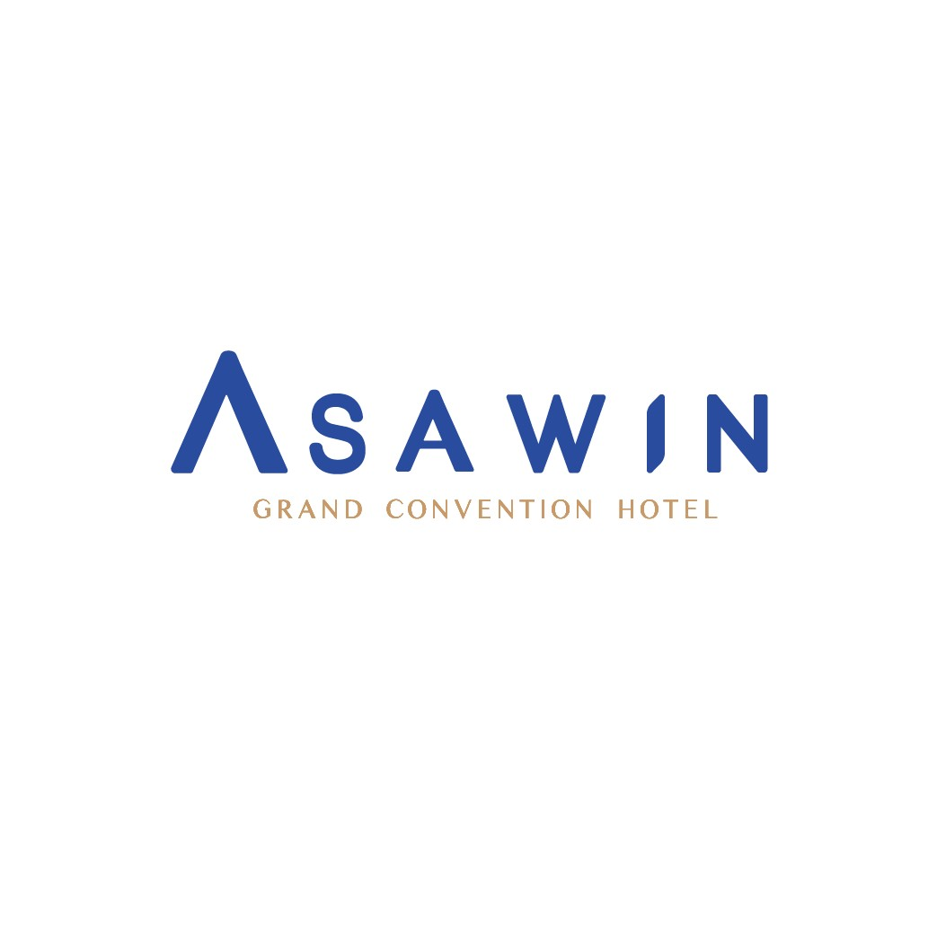

Booking Detail

Event Name **i-CREATe 2023**

Venue **Asawin Grand Convention Hotel**

Arrival Date ........................................................................................................................

- Premier room (single) with Daily buffet breakfast at 2,000.-THB/room/night.

- Premier room (twin) with Daily buffet breakfast at 2,200.-THB/room/night.

*(Above rates are included 10% service charge and 7%Government tax.)*

**TERMS & CONDITIONS:**

**-** Expenses incurred during the stay will be charged directly to the guest.

- To confirm the reservation, send the form back to the hotel. ready to send email [reservation@asawinhotel.com](mailto:reservation@asawinhotel.com) ,CC. [fom@asawinhotel.com](mailto:fom@asawinhotel.com) Or contact for more information directly Asawin Grand Convention Hotel Tel. 02-159-5888 #1102-1103

**Hotel Bank Account**

A/C Name : MAGIC ENTERPRISE CO., LTD

Bank Name : Bank of Ayudhya Public., Ltd.

Branch : Vibhavadi Rangsit Road, (Sun Tower)

A/C No. : 348-135548-2 / Savings A/C

Swift Code : AYUDTHBK

Hotel Name : ASAWIN GRAND CONVENTION HOTEL

Hotel Address : 88 Vibhavadi Rangsit Road (Kamphaeng Phet 6), Talad Bang Khen Subdistrict,Lak Si District, Bangkok 10210

Hotel Tax ID.No : 010-553-805 3724

Telephone : +66 (0) 2 159-5888 Fax: +66 (0) 2 159-5887

Note: **- Reservations with prepayment cannot be changed and/or canceled in any way, and sums paid in advance as a deposit cannot be refunded. This is indicated in the conditions of sale for the rate. Closed for booking on 24 July 2023.**

**Name List**

1 ........................................................................................................................

2 ........................................................................................................................

Arrival Date ......................................................... Time : 14:00 hrs.

Departure Date ......................................................... Time : 12:00 hrs.

Address for issuing receipts (Please specify in detail clearly)

.........................................................................................................................................................................................................................................

.........................................................................................................................................................................................................................................

Tel: .............................................................................. Email ..............................................................................